**XPRIZE Power Systems Group**

**Test Plan**

Hayes Griffin, Frank Jones, Ernesto de Losada, Henry Meiring,Nigel Malaba

**I. Purpose**

The power system we have inherited has not been tested for output or effectiveness in any way. This test plan is an attempt to measure power generation and fuel consumption. Initially, we are concerned with performance under varying load conditions at full throttle. This same format and setup will be used for future tests of the power system.

Efficiency is also important to measure because it will ultimately affect how many drones will need to be built in order to complete the full XPRIZE mission. Dr. Brooke has initially assumed a 10% efficiency to gain a rough estimate of how many drones will be needed, but both he and the team believe this is a conservative estimate, and efficiencies of closer to 15% may be possible.

**II. List of Materials**

|  |  |  |  |  |
| --- | --- | --- | --- | --- |
| Quantity | Material | Part Number | Unit Price | Total Price |
| 3 | Electric Water Heater Element, 1,500 W at 240 V | 35555K34 | $11.07 | $33.21 |
| 1 | Electric Water Heater Element, 4,500 W at 240 V | 35555K32 | $9.22 | $9.22 |
|  | Wire rated for 70 A | - | - | - |
|  | Alligator clips | - | - | - |
| 1 | Board of plywood | - | - | - |
| 1 | Bucket (5 gallons) | - | - | - |
| 1 | Graduated cylinder | - | - | - |
| 1 | Plug-in Voltage Transformer | 70235K23 | 16.18 | $16.18 |

**Total: $58.61**

All materials without an MMC part number given were available in the lab and were not purchased.

**III. Setup**

Four large resistors in the form of water heater elements have been purchased to serve as the load for testing. The resistors will be arranged in a bucket of water with a constant inflow and outflow to maintain low temperature. The resistors are wired to the generator and the engine will be supplied fuel from a graduated cylinder.

**IV. Methodology**

To test the power system at varying loads, the resistors can be wired in varying combinations of series and parallel. The following sheet provides schematics for the possible variations, with identical circuits (with varied resistance) grouped by color. The system will then be turned on. Voltage measurements across the resistor network will be taken and used to calculate power generated. The system will be run for a sufficient amount of time to measure fuel consumption.

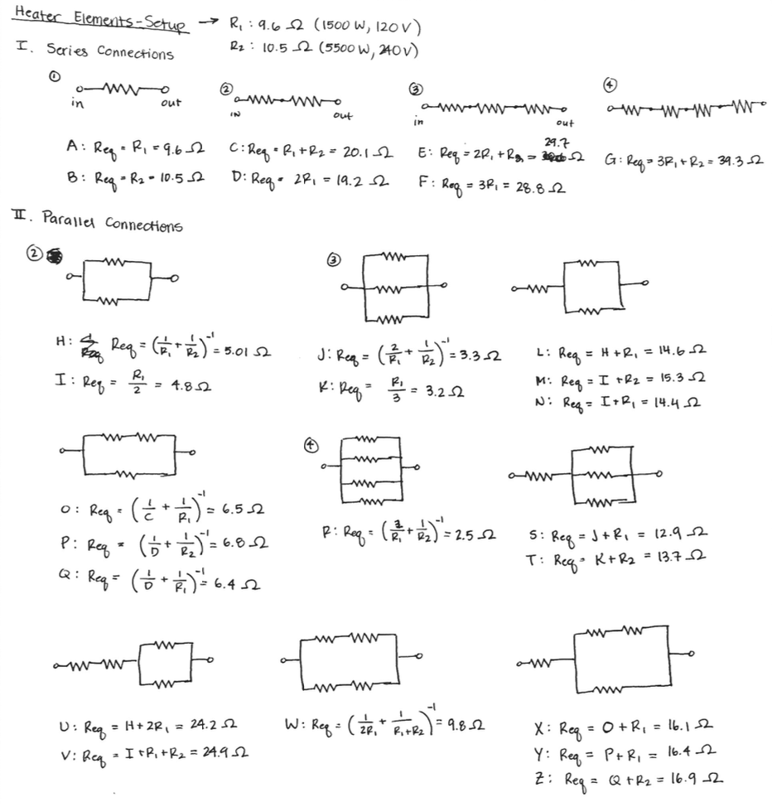

|  |  |  |  |  |  |  |  |  |  |
| --- | --- | --- | --- | --- | --- | --- | --- | --- | --- |
| **Network** | **A** | **B** | **C** | **D** | **E** | **F** | **G** | **H** | **I** |
| Resistance (Ω) | 9.6 | 10.5 | 20.1 | 19.2 | 29.7 | 28.8 | 39.3 | 5 | 4.8 |
| **Network** | **J** | **K** | **L** | **M** | **N** | **O** | **P** | **Q** | **R** |
| Resistance (Ω) | 3.3 | 3.2 | 14.6 | 15.3 | 14.4 | 6.5 | 6.8 | 6.4 | 2.5 |
| **Network** | **S** | **T** | **U** | **V** | **W** | **X** | **Y** | **Z** |  |
| Resistance (Ω) | 12.9 | 13.7 | 24.2 | 24.9 | 9.8 | 16.1 | 16.4 | 16.9 |  |